Insurance companies:
OBF
IACP negotiated professional indemnity insurance scheme with O’Brien Finlay: Qualified Therapist - €75 discount, Students - €160 discount. Contact for OBF: (01) 660 1033.
Details: https://www.obf.ie/qualified-practitioners-insurance/

BMIB Ltd t/as Brian Mullins Insurance Brokers
BMIB have IACP Member’s Group Insurance:
How much does it cost?
The total amount due for 12 months cover under our Group Policies is €110.00. This amount includes the 5% government levy and €10.00 brokerage fee.
Am I eligible for this policy?
In order to apply for this policy, you must be an Accredited or Pre-Accredited IACP member. You must hold the approved qualification to carry out the treatments you request cover for. We cannot offer cover for Affiliated members. If you are a Student member, please contact our office for a quote. Student policies cannot be processed through the website.
Details: https://bmib.ie/counselling-insurance/#schemes

Brady Insurance
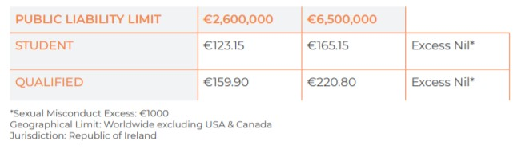
Details: https://www.bradyinsurance.ie/business-insurance/therapy

