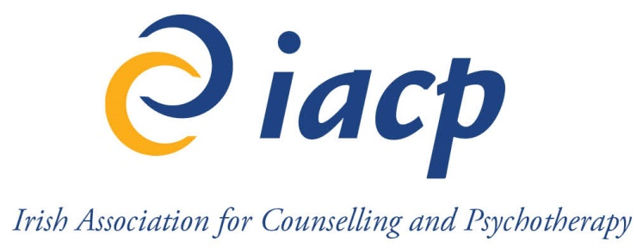 | IACP CPD Recognition for External Events / Courses Application Form

A person proposing to organise a course / event (Organiser) applies for CPD recognition for the course / event by competing the IACP CPD Recognition Application Form. Please support the application with the course brochure and any promotional materials that might be relevant.
Completed applications including supporting documentation should be submitted by post or email to Kate Privett-Collins, Accreditation Officer, CPD Recognition Section, Irish Association for Counselling & Psychotherapy, First Floor, Marina House, 11-13 Clarence Street, Dun Laoghaire, Co. Dublin or kate@iacp.ie at least six weeks in advance of the proposed date for the course / event.

TITLE OF EVENT / COURSE

LOCATION / VENUE, DATE(S)
Location:
Venue:
Dates:

Documents will be destroyed after an appropriate period of time as per the IACP Retention policy. Do not send any original documents unless specifically requested. Keep a copy of any application forms/correspondence you send to IACP for your own records.
ORGANISER CONTACT DETAILS, BIOGRAPHY / ACCREDITATION DETAILS (If applicable)
Full Name:
Address:
Website:

Telephone Number: |  | Email address:

Information for the invoice (if different than above):

Do you wish to advertise your event on the IACP Website in external events section? Y/N

Education / Qualifications Details:
Accreditation Details:
References:

Biography / Credentials:

EDUCATIONAL OBJECTIVES OF THE EVENT

SPEAKERS / FACILITATORS (If applicable)
(Evidence is required that the presenters and / or facilitators have the expertise to deliver the learning objectives using the methods chosen.)
SPEAKER / FACILITATOR 1
Full Name:

Contact Number: |  | Email address:

Biography / Credentials:

SPEAKER / FACILITATOR 2
Full Name:

Contact Number: |  | Email address:

Biography / Credentials:

SPEAKER / FACILITATOR 3
Full Name:

Contact Number: |  | Email address:

Biography / Credentials:

SPEAKER / FACILITATOR 4
Full Name:

Contact Number: |  | Email address:

Biography / Credentials:

SPEAKER / FACILITATOR 5
Full Name:

Contact Number: |  | Email address:

Biography / Credentials:

SPEAKER / FACILITATOR 6
Full Name:

Contact Number: |  | Email address:

Biography / Credentials:

LEARNING OUTCOMES
Describe the learning outcomes to be acquired as a result of attending the course / event and how they link to good professional practice.

LEARNING / METHODS
Which Learning / teaching methods will be used e.g. lectures, workshops, tutorials etc.

PROGRAMME / SCHEDULE / AGENDA

- An outline of the educational content

- A full schedule for the course/ event, indicating start and finish times of each activity

- Name and appointment of each speaker and full title of their presentation

METHOD OF EVALUATION (feedback form, quiz or other form of assessment)

SPONSORSHIP – provide a list of sponsors if applicable

OTHER INFORMATION REGARDING THE COURSE / EVENT
- Proposed Number of Attendees for the event:
- Contact person for making reservations and enquires (link to the online reservation)
- Fees and fees breakdown (what is included in the price, e.g. materials, coffee breaks, lunch)
- Cancellation and Refunds policy

APPLICATION FEE
This fee is non-refundable and the fee is per event. If you wish to apply for a recurring event, this needs to be clarified within the application form and the fee must be multiplied by the amount of the events planned. There is a discount of 25% for recurring events / courses.
Event organised and / or hosted by a commercial organisation(s): €300
Event organised and / or hosted by a commercial educational provider: €170
Event organised by a registered charity with registration fee: €100
Event organised by a registered charity if the event is free: €50
Event/ training organised by a Public Service Body, relevant to Counselling and Psychotherapy, offered free of charge to participants: no application fee
For short courses (14 CPD points or less) / online courses, it is possible to obtain an annual IACP CPD recognition of the same training course with an annual fee of €500

Number of events applying for:
Total Application Fee applicable:

(Please note this fee is non-refundable.)
METHOD OF PAYMENT: Credit Card by phone OR Cheque included with the application form.

Signature: | Date:

DISCLAIMER
By my signature, I acknowledge that I have read, understand, and agree to the IACP GUIDELINES FOR APPROVAL OF CPD EVENTS.
By submitting this form, I attest that the information provided is true and accurate.

Signed on behalf of Organiser: | Date:

OFFICE USE ONLY
Application meets IACP requirements listed in IACP GUIDELINES FOR APPROVAL OF CPD EVENTS.
CPD Points Awarded for Event / Course:

Signed: | Date:

Application doesn’t meet requirements listed in IACP GUIDELINES FOR APPROVAL OF CPD EVENTS on the following grounds:
_______________________________________________________________________________________________________________________________________________________________________________________________________________________________________________________________________________________
Signed: | Date:

