Weaving the enchanted bridge between

the brain’s two halves from an EMDR perspective © 2025 All Rights Reserved


Linda McGuire & Davy Hutton 2025 © all rights reserved
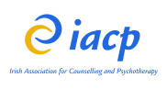
Facilitators:
- Davy Hutton, Snr BACP Clinical Psychotherapist & Supervisor, EMDR Consultant
- Linda McGuire, IACP Clinical Psychotherapist & Supervisor, EMDR Consultant

Venue: Wynne’s Hotel, 35-39 Lower Abbey Street, Dublin
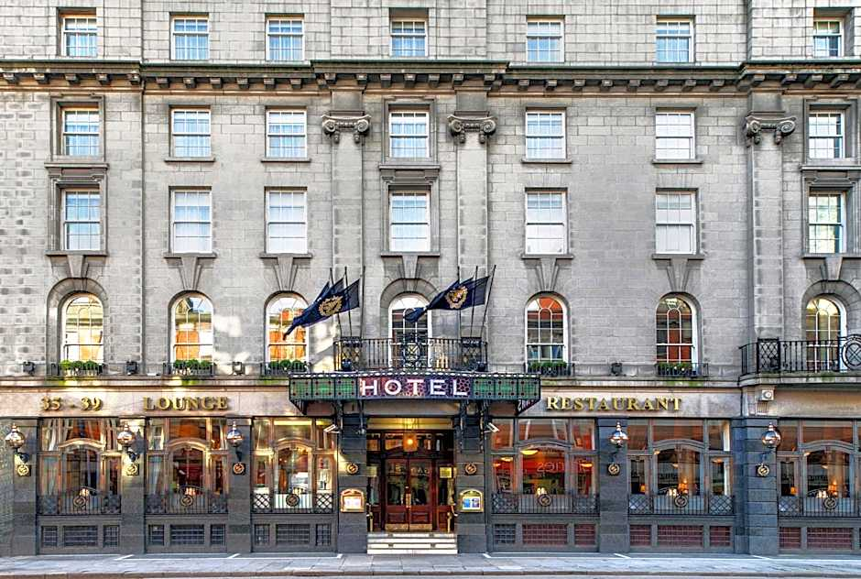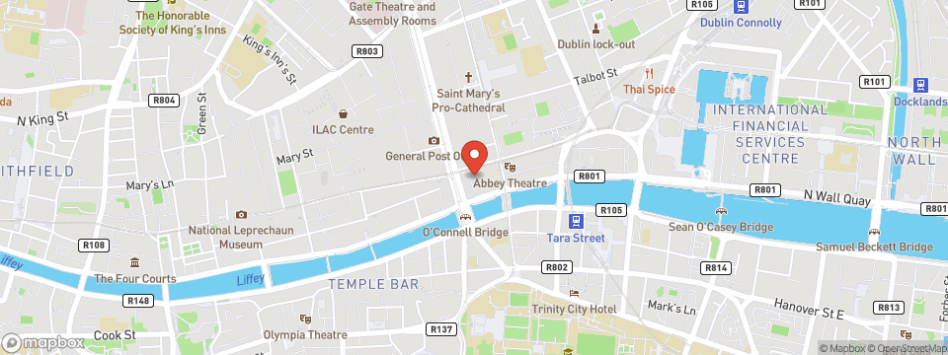

Overview of Workshop:
This immersive, one-day training invites participants to explore the integrative potential of working with both hemispheres of the brain. Through theory, clinical application, and experiential practice, the facilitators will guide participants to deepen their therapeutic skills in weaving the “enchanted bridge that facilitates holistic healing.

Key themes include:
- Understanding hemispheric specialisation and integration in clinical practice
- The role of bilateral stimulation in the therapeutic process
- Creative and embodied approaches to bridging left and right brain functions
- Practical exercises for clinical use with clients

Provisional Schedule:

10.30-11.00 Welcome and Introduction with overview of metaphor in therapy, aims of the workshop

11.00-12.30 Theory and Demonstration on the role of metaphor in uncovering core challenges followed by practical session 1: guided exercises using metaphors for emotional expression

12.30-1.45 Lunch

1.45-3.00 Practical session 2: Small group role plays with feedback from facilitators

3.00 – 3.45 Applied learning: Introducing and practicing the “Room Full of Balloons” script

3.45-4.30 Integrating Skills: Adapting metaphors for complex clinical presentations

4.30 – 5.15 Closing reflections, Q & A and feedback forms

Application Form

Name: __________________________________________________________
Address: ________________________________________________________
________________________________________________________________
Phone: __________________________________________________________
Email: __________________________________________________________
Professional Qualifications:__________________________________________
Accrediting Professional Body/Membership: ____________________________
How will this training best support your clinical practice: ________________________________________________________________
________________________________________________________________
Allergies/Dietary Requirements: (these need to be noted at the point of application)
______________________________________________________

Payment information to secure booking:

€125.00 due at the time of application, payments to be made to the following account:
Name: Linda McGuire
PTSB, Main Street, Newbridge, Co Kildare
IBAN: IE44IPBS99064530169494
BIC: IPBSIE2D
Email contact information for this workshop: lindaemdr@gmail.com

Participants will be expected to attend the workshop in full and complete an end of workshop feedback form ahead of receiving their certificate of attendance.
Cancellations made between 14-20 days before the workshop will receive a 50% refund less a €25 administrative fee.
Cancellations made less than 14 days before the workshop are non-refundable as venue, catering and lecturer travel/accommodation costs will already have been committed to
If a participant cannot attend, they may nominate a suitably qualified substitute delegate at no additional cost provided email notice is given at least 48 hours in advance

In the unlikely event that the workshop must be cancelled by the organisers (e.g. illness, travel disruption, or unforeseen circumstances), an alternative date will be offered, however participants can choose to receive a full refund of the registration fee also
Please note that we are unable to reimburse participants for any travel or accommodation costs they may incur

